Process Improvement Opportunity:

Automating the Pre-Qualification Step:

Enhancing Speed and Accuracy

Target Stakeholder Group: Senior Leaders

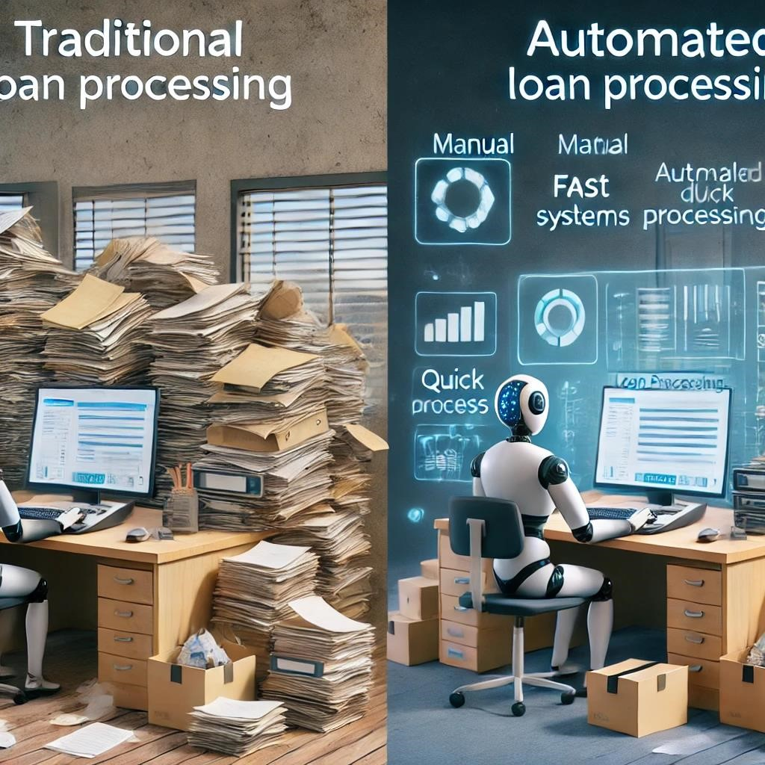"From Days to Minutes: How Automation is Revolutionizing

"From Days to Minutes: How Automation is Revolutionizing Loan Processing."

Cutting pre-qualification time by 50% through automation.

Problem and Solution

•**Process Targeted**: Manual pre-qualification, which is slow and prone to errors.

•**Problem**: Current manual review of applicants’ credit data is time-consuming and resource-intensive.

•**Big Idea**: Implementing AI-based automation to streamline the pre-qualification process, reducing human intervention and improving speed.

Key Points

•**How it Works**: AI automates the review of borrower data, verifying credit, income, and assets instantly.

•**Why It's Important**: Faster processing leads to quicker loan approvals, improving customer satisfaction.

•**Benefits**:

1. 50% reduction in processing time
2. Reduced operational costs
3. Minimized risk of human error
4. Scalable solution for high loan volumes

Summary

•**Leadership Opportunity**: JPMorgan Chase can lead the market in AI-driven pre-qualification automation.

•**Technology is proven**: AI/ML technology is already being implemented successfully in other markets.

•**Key Risk**: The challenge is no longer technology but timely implementation.

•**Competitive Advantage**: JPMorgan Chase has the resources and market strength to scale quickly.

•**Benefits**: 50% faster processing, reduced costs, improved customer satisfaction.

•**Risk of Inaction**: Competitors are advancing; delaying adoption risks falling behind.